Name:- Ritul Srivastava

Reg no. 19BCM0085

Git is a distributed version-control system for tracking changes in source code during software development. It is designed for coordinating work among programmers, but it can be used to track changes in any set of files. It is basically concerned with speed, data integrity, and support for distributed non-linear working.

Important Commands

git clone:-to take a repositiory which is somewhere remotedly present.

git status:-shows on which branch we are

git checkout :-to change the branch

git add:-to include everything in a local folder

git commit:-to commit it with a text

git push:-publish your local commits

ls:-elements present in the repository

git config.:- to set your email and username in the main configuration file

git init :-to initialise a  git repository for a new or existing project.

git branch:- to list all the remote branches

git merge:- merges to branches

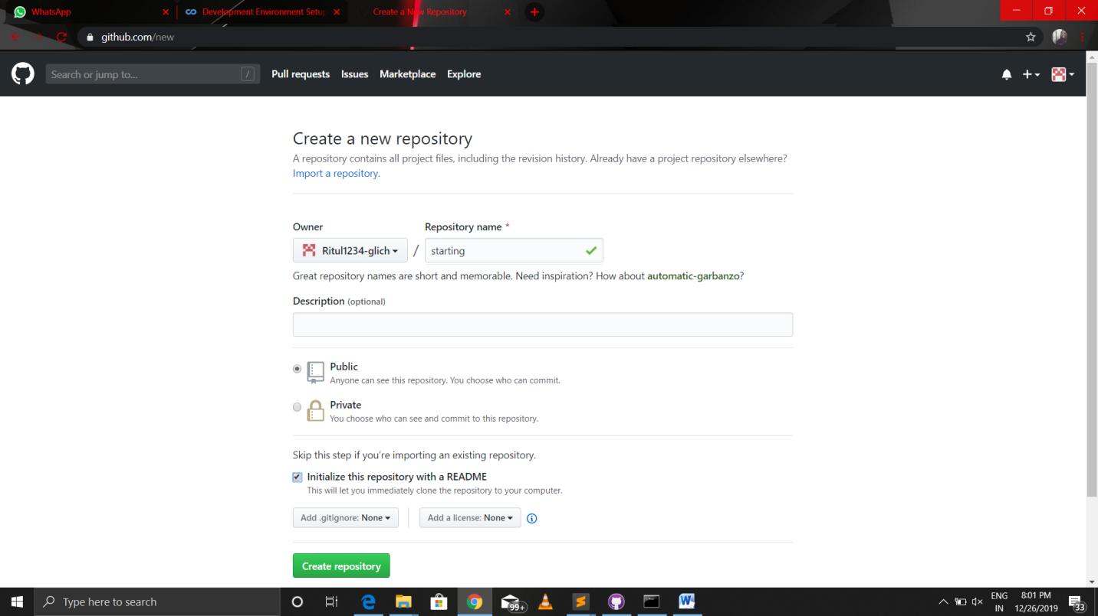

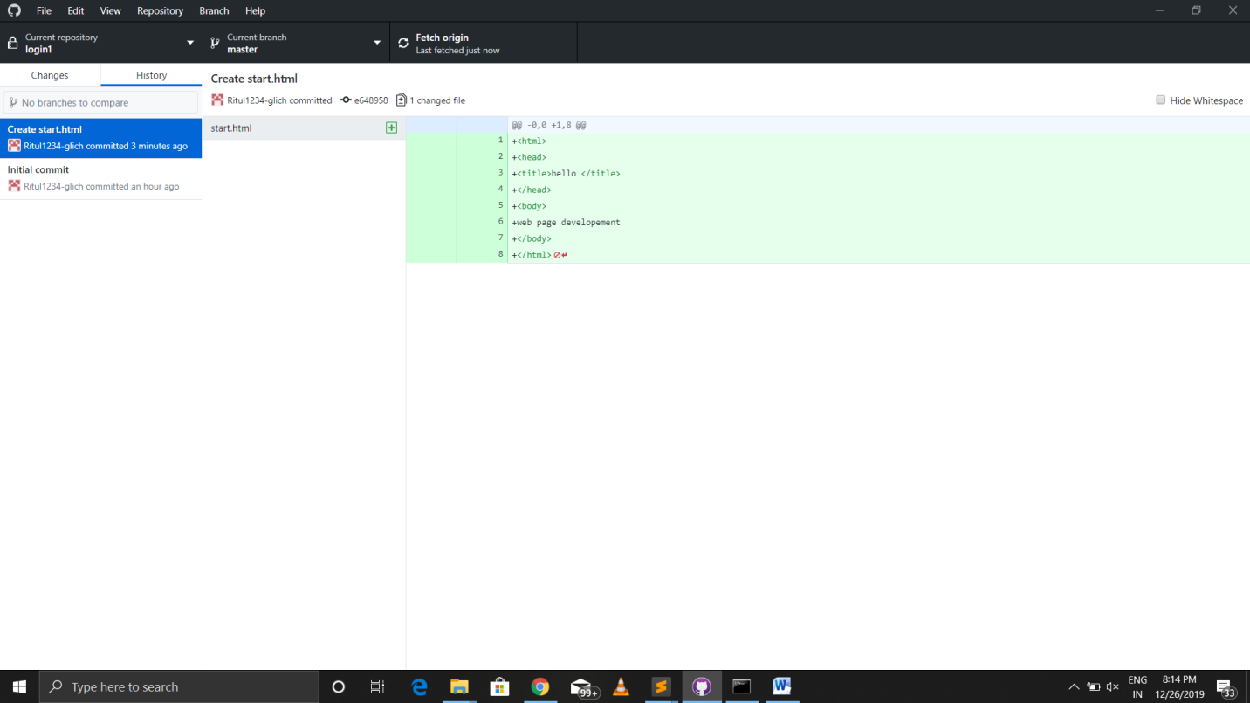

Git username :- <https://github.com/Ritul1234-glitch>

